Part 4: SQL Validation (15 Points)

employees
| id | employee_id | name | email | department |

Write SQL queries for:
- Return all employees and their departments

SELECT employee_id, name, email, department FROM employees;
Explanation:
Displays the employee ID, employee name, and department for all employees.

Eg:
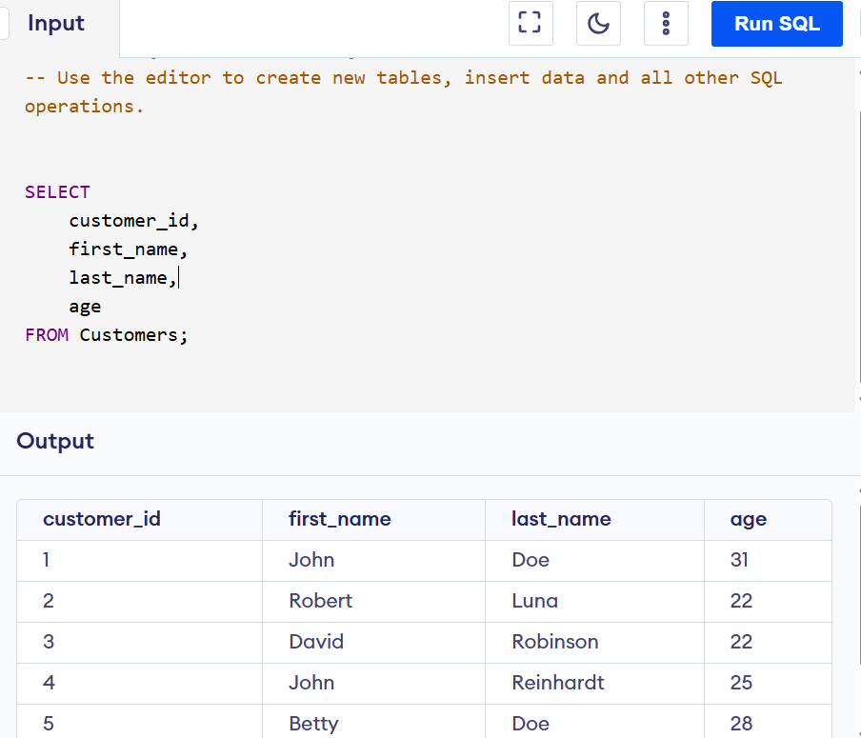

- Return employees who have completed all assigned trainings

SELECT employee_id,
name
FROM employees
JOIN employee_trainings
ON employee.id = employee_trainings.employee_id
GROUP BY employee.id, employee_id, name
HAVING COUNT(*) =
SUM(CASE
WHEN et.status = 'Completed' THEN 1
ELSE 0
END);
Explanation:
Counts all trainings assigned to each employee and compares them with the number of completed trainings. If both counts are equal, the employee has completed all assigned trainings.

Eg:
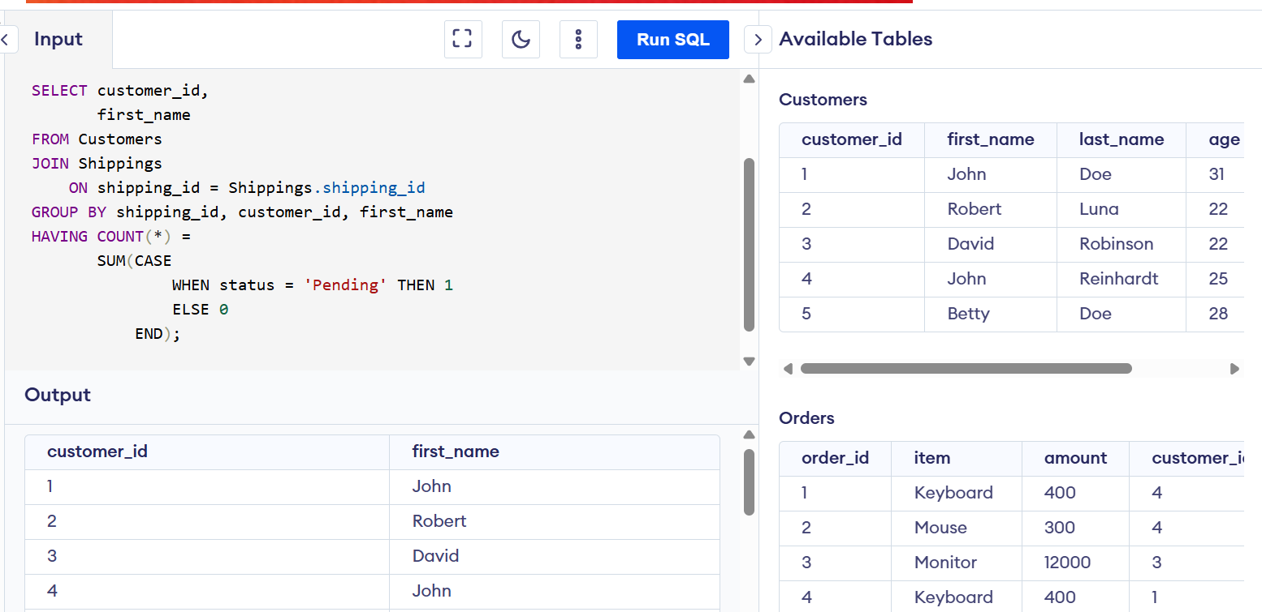

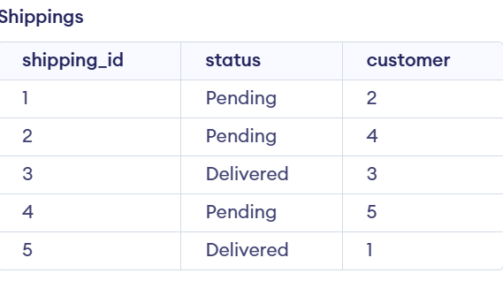

- Count trainings per employee

SELECT employee_id,
name,
COUNT(employee_training.training_id) AS total_trainings
FROM employees
LEFT JOIN employee_trainings
ON employee.id = employee_id.employee_id
GROUP BY employee.id, employee_id, name;

- Certifications expiring within 30
SELECT employee_id,
name,
certification_name,
expiry_date
FROM certifications
JOIN employees
ON employee_id = employee.id
WHERE expiry_date BETWEEN CURRENT_DATE
AND CURRENT_DATE + INTERVAL '30 DAY';

